Game Showcase Instructions

Step by Step to export Godot and upload to itch.io

Step 1:
Go to https://itch.io/

Step 2:
Register as a developer:
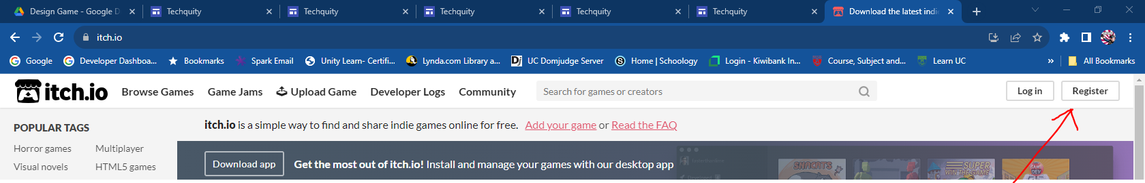

Don’t forget to tell them you’d like to upload!
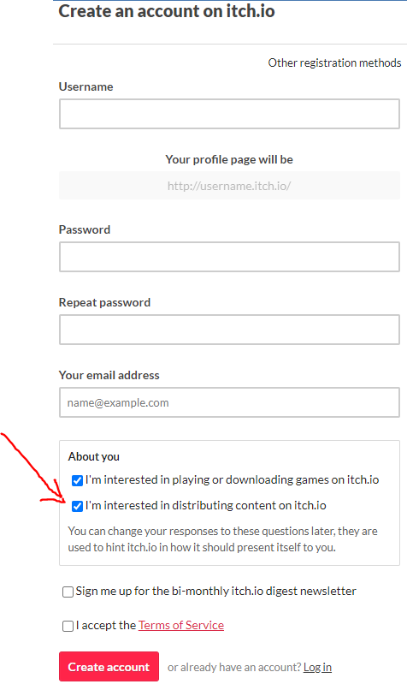

Step 3:
Create a new Project

Click on your developer Dashboard and Create a new project. You can have as many projects as you like and you have complete control over them.
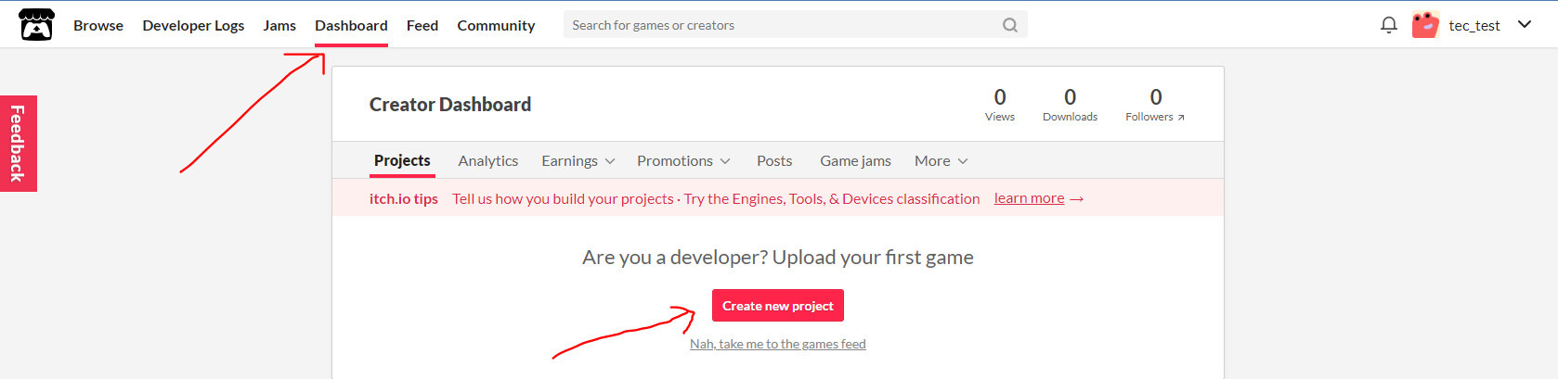

Fill out the Project information page.
Make sure you choose “Kind of Project” as HTML if you want it to play in browser.
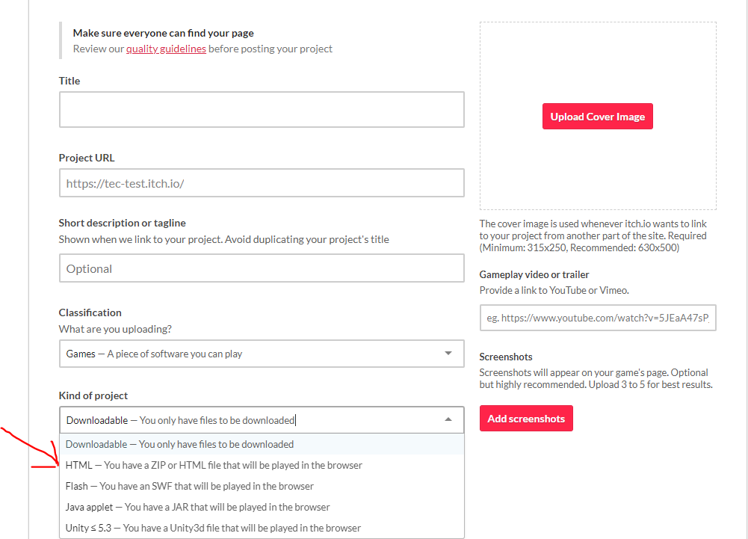

Pay attention to the information here.
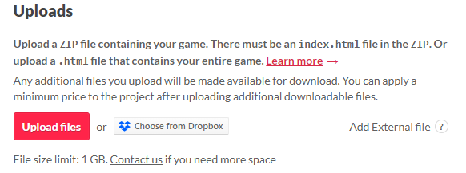

Export Godot Correctly:

In Godot, make sure the Renderer is set to Compatibility:
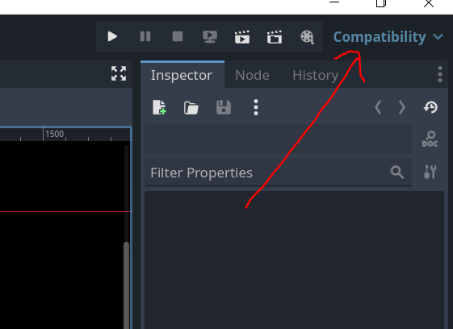

Choose Export from the file menu
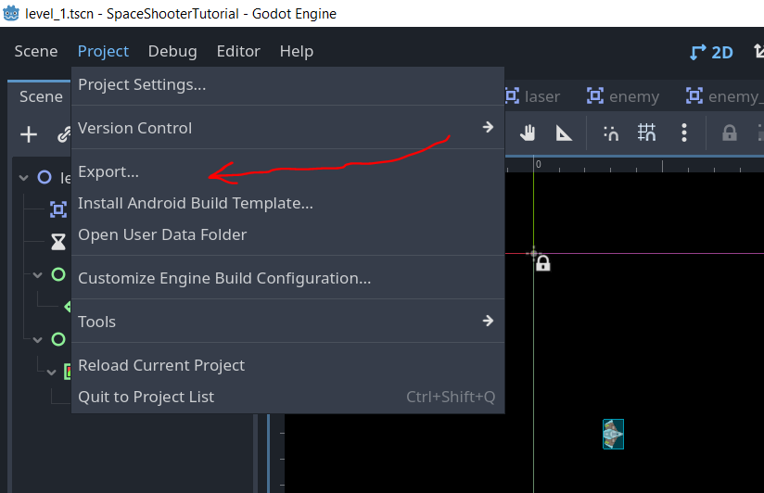

In the export window. If you haven’t already got the Web Export, select it, download it and install it.
Now choose web and export project:
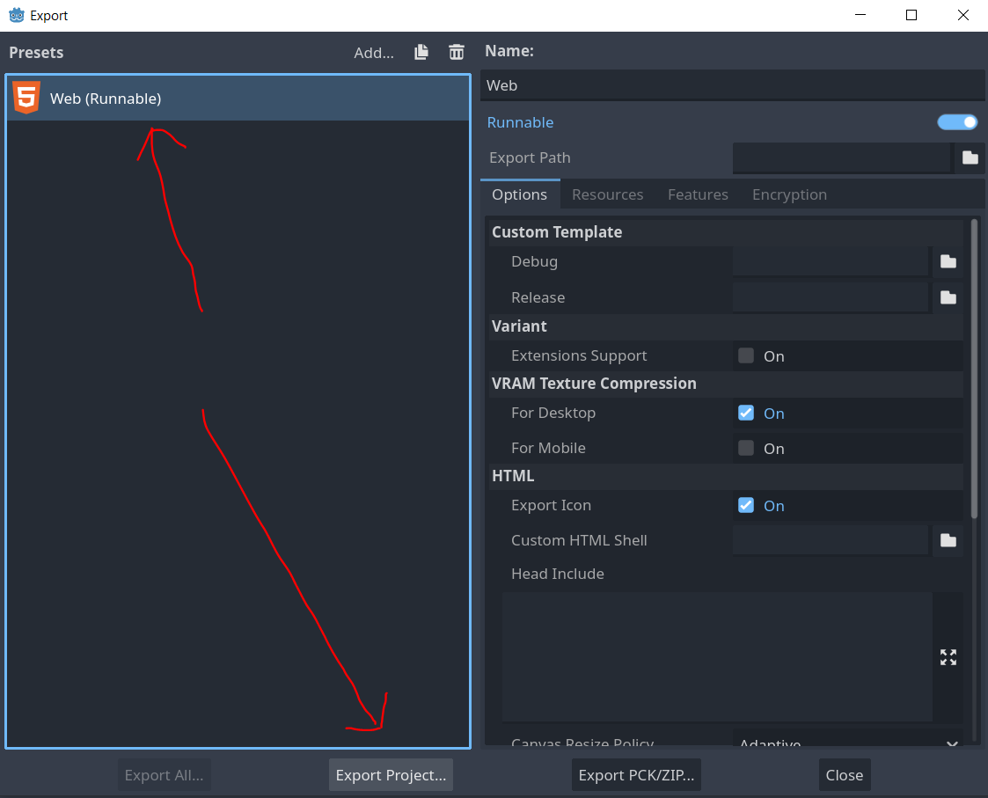

Change the filename to index.html
It won’t work without you doing that!!
Create a brand new empty folder for your game build (mine is called mygamebuild)
And then Export the Project into the new empty folder

Now in the file explorer, zip/compress that folder.
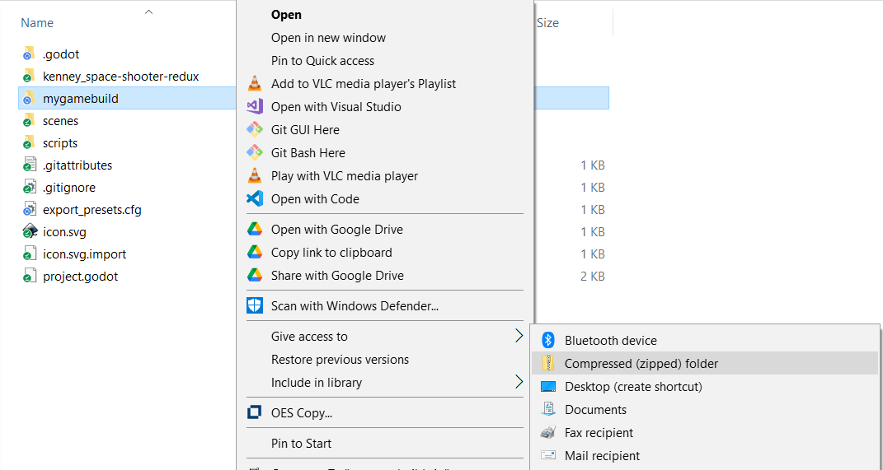

It is the ZIP that you need to upload to itch.io.

Back in itch.io:

Set the Embed Options Correctly.
Make sure you have set the Viewport Dimensions to the same as your game. If you haven;t changed them in your Godot Project Settings they will be
Width: 1152
Height: 648

AND TICK THE SharedArrayBuffer support:
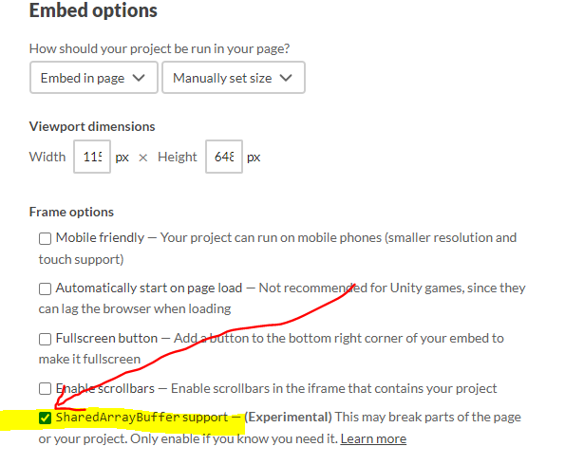

Test to see if your game loads.
Down the bottom the page is the visibility. Here you can make it public AFTER you have tested that it works. You can “Save and View Page” now to see that your game loads.
